**SSN COLLEGE OF ENGINEERING, CHENNAI**

**UCS2611 – Internet Programming Lab**

**1. Write an HTML program to display the following using inline, embedded and external stylesheets:**

**Ques1.html**

<!DOCTYPE html>

<html>

    <head>

        <title>Question 1</title>

        <style>

            /* body {

                background-color: yellow;

            } */

            .Tabspace {

                margin-left: 50px;

            }

            p{

                color:azure;

            }

        </style>

        <link rel="stylesheet" href="style.css">

    </head>

    <body>

        <p>Web programming is used to create websites, online stores, web applications, and other online services that are accessed through the Internet.</p>

        <div class="Tabspace">

            <p style="background-color: red;">Web programming languages like HTML, CSS, JavaScript, PHP, and Python are used to create these web-based applications.</p>

            <br>

            <p>Client Side Technologies are the tools and languages that run in the user's web browser, rather than on a web server. </p>

            <p>They determine how the content will be displayed to the end-user. </p>

            <p>Some popular client-side technologies you might have heard of include HTML, CSS, and JavaScript.</p>

            <br>

            <p>The term 'server-side technologies can encompass a range of software solutions, </p>

            <p>mainly: server-side scripting languages;</p>

            <p>Database Management Systems (DBMS); web server software such as Apache;</p>

            <p>and many other technologies depending upon the application being built.</p>

        </div>

    </body>

</html>

**Style1.css**

body{

    background-image: url("https://images.pexels.com/photos/1229042/pexels-photo-1229042.jpeg?auto=compress&cs=tinysrgb&w=1260&h=750&dpr=1");

    background-repeat: no-repeat;

    background-size: cover;

}

**Output:**

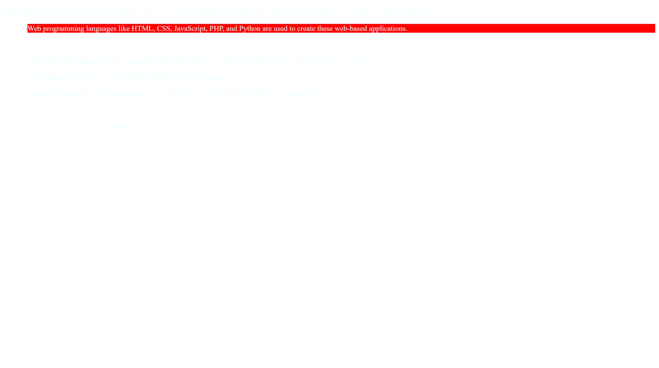

**2. Given the following style file and the output snapshot, write HTML code recreate the output. Write down the types of selectors inheritance used in the code.**

**Ques2.html**

<!DOCTYPE html>

<html>

    <head>

        <title>Question 2</title>

        <link rel="stylesheet" href="style2.css">

    </head>

    <body>

        <p>P tag - This is a sample Web Page</p>

        <div id="p2">one</div>

        <p id="p2">P tag -  How are you?</p>

        <p><a href="https://snuchennai-entrance.codetantra.com/login.jsp" target="_blank">P tag - I am fine</a></p>

        <p><b>This is SSN College of Engineering</b></p>

        <div>

            <ol type="1" style="color:red">

                <li>One</li>

                <li>Two</li>

                <li>Three</li>

            </ol>

        </div>

        <div>

            <p id="box">

                What is the CSS Box Model? The CSS box model is a

                container that contains multiple properties including

                borders, margin, padding, and the content itself. It is

                used to create the design and layout of web pages.

                According to the CSS box model, the web browser

                supplies each element as a square prism.

            </p>

        </div>

    </body>

</html>

**Style2.css**

p{

    font-size:x-large;

    background-color: lime;

}

*{

    font-family: monospace;

}

a:link{color:black;}

a:visited{color:yellow;}

a:hover{color:blue;}

a:active{color:red;}

#p2{

    color:yellow

}

#box

{

    background-color: white;

    border: 10px dotted blue;

    width:32%;

    padding: 20px;

    margin:30px 20px;

}

**Output:**

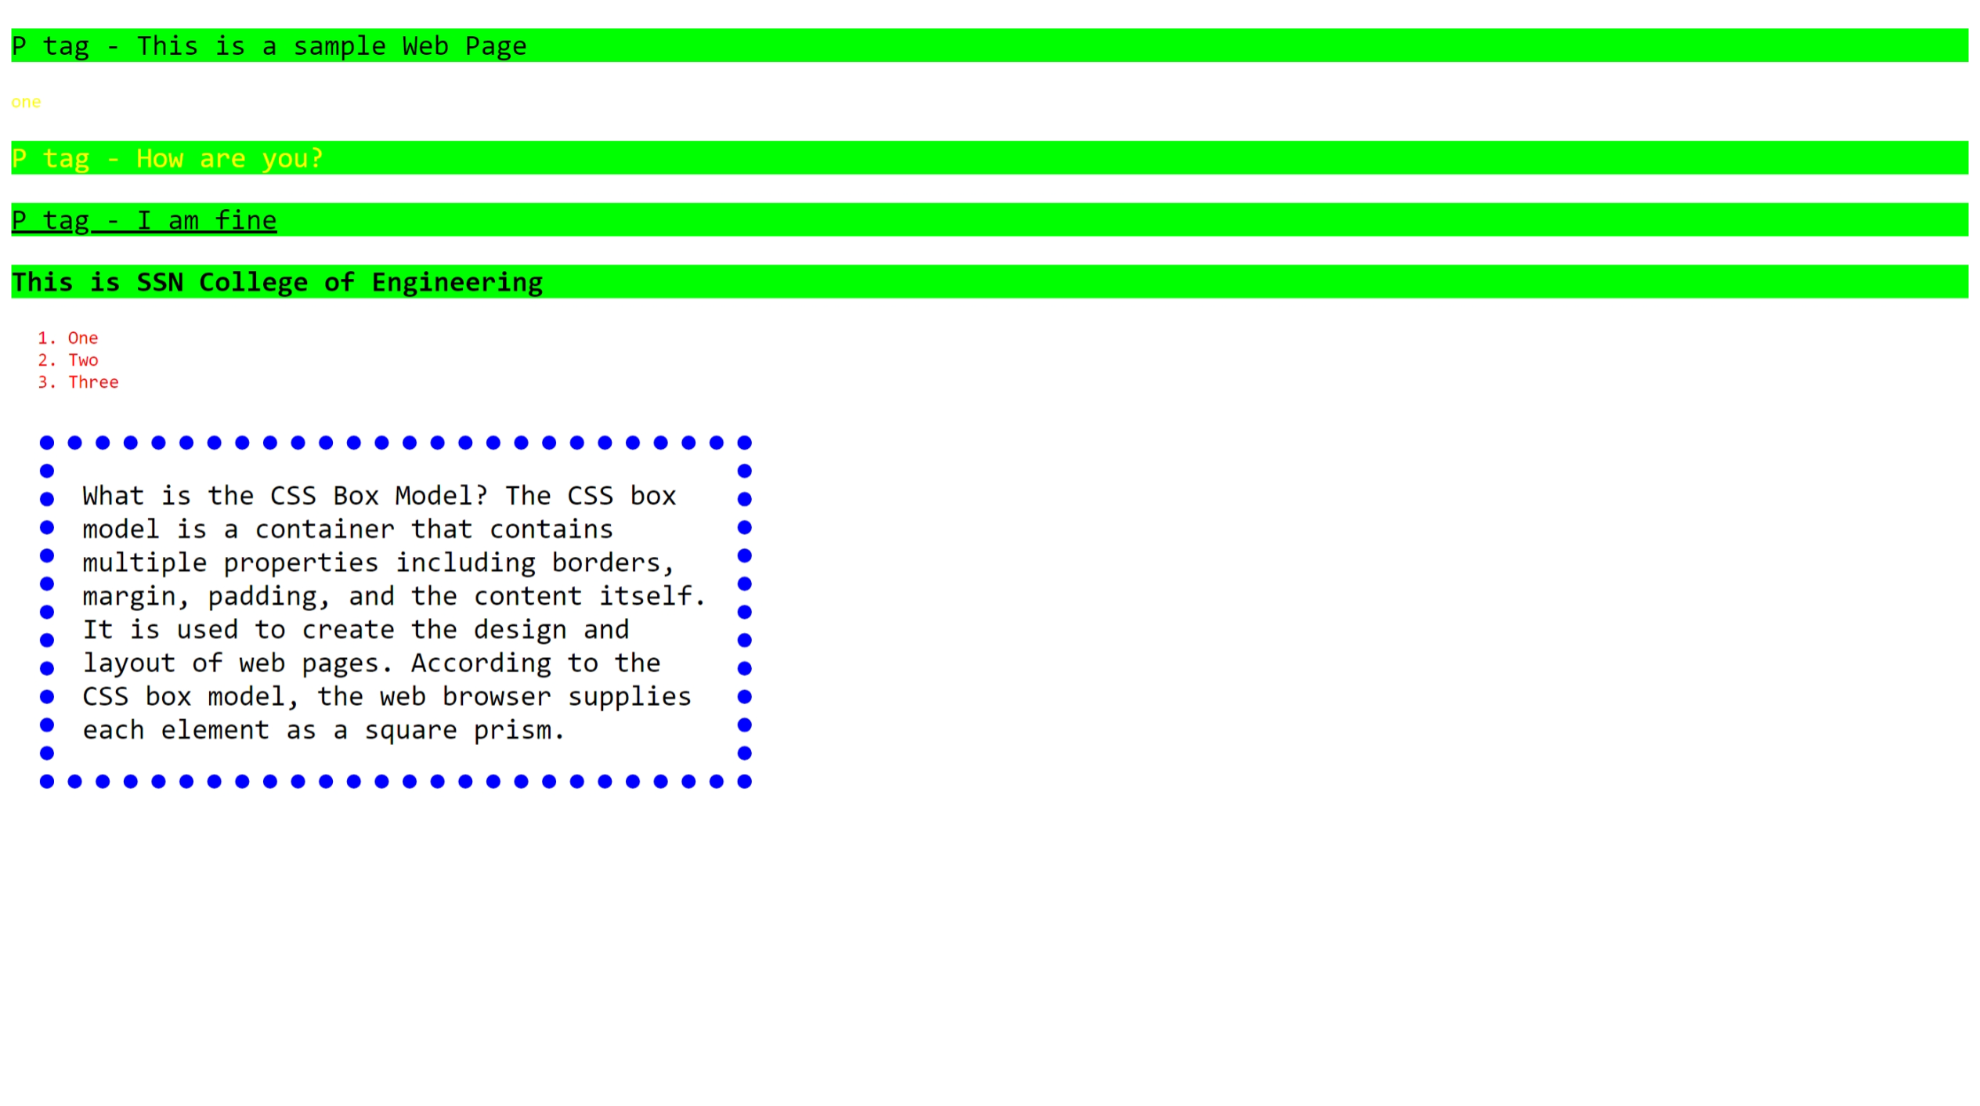

**3. Place html, body, div, span elements and highlight the boxes of these elements using different styles using border, margin, and padding properties of CSS box.**

**Ques3.html**

<!DOCTYPE html>

<html>

    <head>

        <title>Question 3 </title>

        <link rel="stylesheet" href="style3.css">

    </head>

    <body>

        <div class="BlueBox">

            <div class="RedBox">

                <div class="PinkBox">

                    <div id="div1">

                    </div>

                    <div id="div2">

                    </div>

                    <div id="div3">

                    </div>

                </div>

                <div id="cat">

                    <div id="cat1">

                    </div>

                    <div id="cat2">

                    </div>

                    <div id="cat1">

                    </div>

                    <div id="cat2">

                    </div>

                </div>

            </div>

        </div>

    </body>

</html>

**Style3.css**

.BlueBox{

    border: dashed blue;

    margin: 10px;

    min-height: 90vh;

}

.RedBox{

    border: dashed red;

    margin:10px;

    min-height: 90vh;

}

.PinkBox{

    border: solid purple;

    margin: 10px 700px 10px 10px;

    min-height: 45vh;

}

#div1{

    background-color: yellow;

    border: dashed green;

    margin:20px 500px 20px 20px;

    min-height: 10vh;

}

#div2{

    background-color: yellow;

    border: dashed pink;

    margin:10px 500px 20px 20px;

    min-height: 10vh;

}

#div3{

    background-color: yellow;

    border: dashed red;

    margin:10px 500px 20px 20px;

    min-height: 10vh;

}

#cat div{

    display: inline-block;

}

#cat1{

    background-color: yellow;

    border: dashed green;

    margin:20px 20px 20px 20px;

    min-height: 10vh;

    min-width: 100px;

}

#cat2{

    background-color: yellow;

    border: dashed red;

    margin:20px 20px 20px 20px;

    min-height: 10vh;

    min-width: 100px;

}

**Output:**

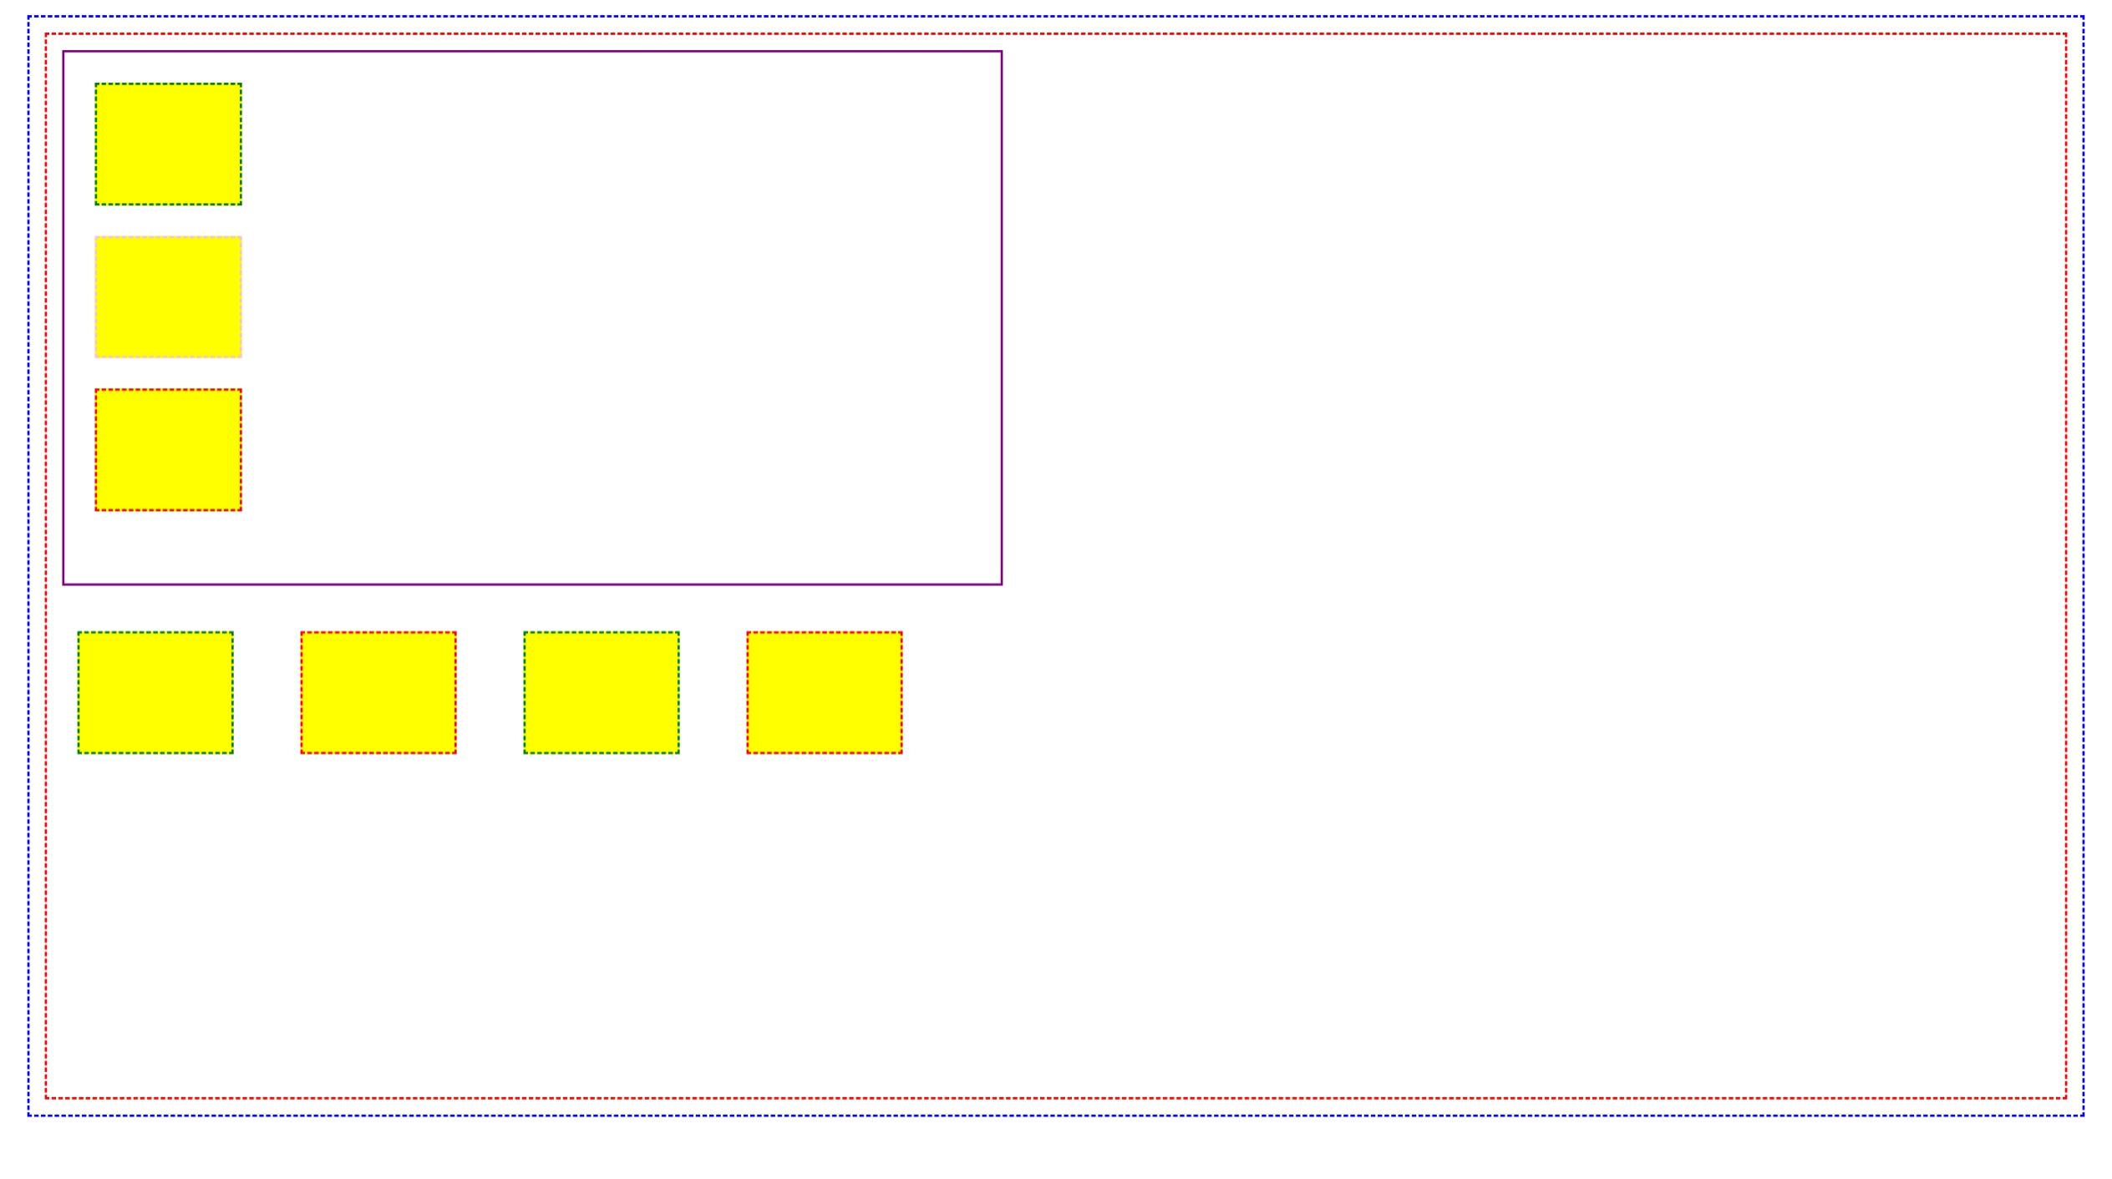

**4. Place the background image and highlight the word *tree* using span element with the given style**

**Ques4.html**

<!DOCTYPE html>

<html>

    <head>

        <title>Question 4</title>

        <link rel="stylesheet" href="style4.css">

    </head>

    <body>

        <div class="box">

            <div class="innerbox">

                <p>In botany, a <span>TREE</span> is a perennial plant with an elongated stem, or trunk, usually supporting branches and leaves. In some usages, the definition of a <span>TREE</span> may be narrower, including only woody plants with secondary growth, plants that are usable as lumber or plants above a specified height. In wider definitions, the taller palms. <span>TREE</span> ferns, bananas, and bamboos are also trees. Trees are not a monophyletic taxonomic group but consist of a wide variety of plant species that have independently evolved a trunk and branches as a way to tower above other plants to compete for sunlight. The majority of <span>TREE</span> species are angiosperms or hardwoods; of the rest. many are gymnosperms or softwoods. Trees tend to be long-lived, some reaching several thousand years old. Trees have been in existence for 370 million years. It is estimated that there are around three trillion mature trees in the world.</p>

            </div>

            <img src="https://img.freepik.com/free-vector/isolated-tree-white-background_1308-26130.jpg" alt="hello">

        </div>

    </body>

</html>

**Style4.css**

.box{

    border: dashed red;

    margin: 10px;

    min-height: 90vh;

}

.innerbox{

    border: solid blue;

    margin: 30px;

    /* min-height: 50vh; */

    width: 580px;

}

img{

    width: 150px;

    position: relative;

    top:200px;

    left: 85%;

}

span{

    background-color: yellow;

}

**Output:**

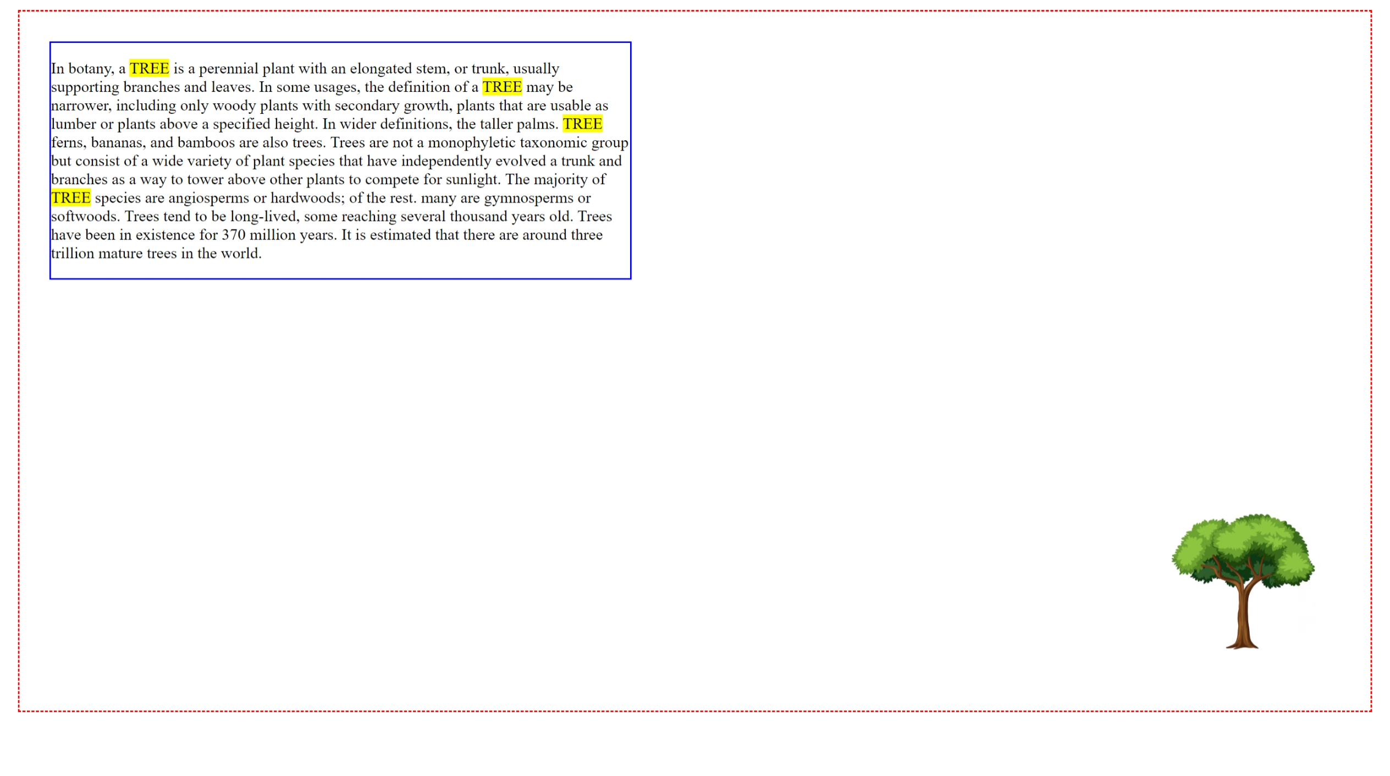

**5. Create the definition of fruits using background image and float the word *fruit* using the following style.**

**Ques5.html**

<!DOCTYPE html>

<html>

    <head>

        <title>Question 5</title>

    </head>

    <link rel="stylesheet" href="style5.css">

    <body>

        <div class="box">

            <div class="tabspace">

                <p>Fruit is good for you, but what is the healthiest fruit? All fruit offer health benefits, so include as much variety as possible. "An apple a day keeps the doctor away." or so the saying <span>Fruit</span> goes. Healthcare professionals know that fruit is a highly nutritious, delicious, and convenient addition to any diet. With more than 2.000 varieties of fruit available, you may wonder which ones you should pick. Each type of fruit brings its own unique set of nutrients and benefits to the table. The key is to eat fruits of various colors, as each color provides adifferent set of healthy nutrients.</p>

            </div>

            <img src="https://images.pexels.com/photos/235294/pexels-photo-235294.jpeg?cs=srgb&dl=pexels-photomix-company-235294.jpg&fm=jpg" alt="Image">

        </div>

    </body>

</html>

**Style5.css**

.box{

    border: dashed blue;

    margin-left: 10px;

    min-height: 90vh;

    margin: 50px;

}

.tabspace{

    margin: 50px;

}

span{

    font-size: 40px;

}

img{

    width: 400px;

    position: relative;

    top:200px;

    left: 65%;

}

**Output:**

